**Exercise 1: Setting Up JUnit**

**1. pom.xml Dependency for JUnit 4.13.2**

<dependencies>

<dependency>

<groupId>junit</groupId>

<artifactId>junit</artifactId>

<version>4.13.2</version>

<scope>test</scope>

</dependency>

</dependencies>

**Calculator.java**

public class Calculator {

public int add(int a, int b) {

return a + b;

}

public int multiply(int a, int b) {

return a * b;

}

}

**Sample JUnit Test Class (CalculatorTest.java)**

import org.junit.Test;

import static org.junit.Assert.*;

public class CalculatorTest {

@Test

public void testAddition() {

Calculator calc = new Calculator();

int result = calc.add(2, 3);

assertEquals(5, result);

}

@Test

public void testMultiplication() {

Calculator calc = new Calculator();

int result = calc.multiply(4, 2);

assertEquals(8, result);

}

}

Output:



**Exercise 3: Assertions in JUnit**

**1. JUnit Test Class: AssertionsTest.java**

import org.junit.Test;

import static org.junit.Assert.*;

public class AssertionsTest {

@Test

public void testAssertions() {

// Assert equals

assertEquals(5, 2 + 3);

// Assert true

assertTrue(5 > 3);

// Assert false

assertFalse(5 < 3);

// Assert null

assertNull(null);

// Assert not null

assertNotNull(new Object());

}

}

Output:

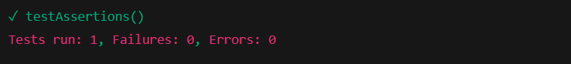

Output If One Fails:

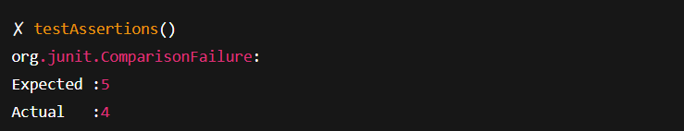

**Exercise 4: Arrange-Act-Assert (AAA) Pattern, Test Fixtures, Setup and Teardown Methods in JUnit**

**Java Class to Be Tested: Calculator.java**

public class Calculator {

public int add(int a, int b) {

return a + b;

}

public int divide(int a, int b) {

return a / b;

}

}

**JUnit Test Class Using AAA Pattern and Fixtures: CalculatorTest.java**

import org.junit.After;

import org.junit.Before;

import org.junit.Test;

import static org.junit.Assert.*;

public class CalculatorTest {

private Calculator calculator;

@Before

public void setUp() {

// Arrange: setup before each test

calculator = new Calculator();

System.out.println("Setup completed.");

}

@After

public void tearDown() {

// Cleanup after each test

calculator = null;

System.out.println("Teardown completed.");

}

@Test

public void testAdd() {

// Act

int result = calculator.add(10, 5);

// Assert

assertEquals(15, result);

}

@Test

public void testDivide() {

// Act

int result = calculator.divide(10, 2);

// Assert

assertEquals(5, result);

}

}

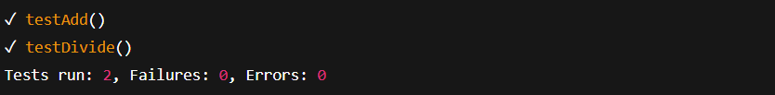Output:

